Spring Boot Auto-Configuration (How It Really Works)

Why Auto-Configuration Exists
Spring solved object management using IoC & DI.
But it did not solve configuration explosion.
A real Spring app needs:
• DataSource
• TransactionManager
• EntityManagerFactory
• DispatcherServlet
• Jackson
• ComponentScan
• Hibernate dialects
Before Spring Boot, developers wrote hundreds of lines of config before writing a single API.
Spring Boot exists to answer this question:
“If we already know what libraries you are using… why should you configure them?”
Auto-Configuration is Spring Boot’s brain.

What is Spring Boot Auto-Configuration?
Spring Boot Auto-Configuration is:
A collection of pre-written Spring @Configuration classes that are automatically activated based on what is present in your class path and environment.
It is implemented in the JAR:
spring-boot-autoconfigure
Inside it are hundreds of classes like:
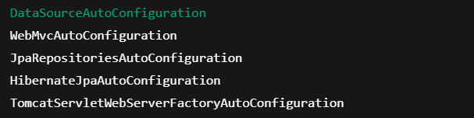
Each one contains the default enterprise-grade configuration you would normally have to write yourself.

Where Auto-Configuration Is Plugged In
When you write:
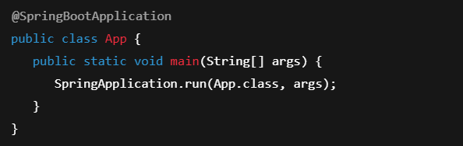
@SpringBootApplication expands to:
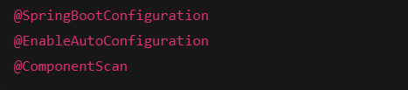 @EnableAutoConfiguration triggers:
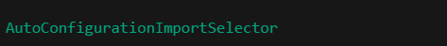
Which loads all auto-configuration classes from:
These are the files that list every Auto-Config class in Boot.

How Spring Boot Decides What To Create
Every auto-config class uses conditional annotations.
Example:
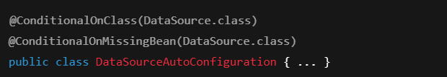 Meaning:
• If DataSource is on the classpath
• AND you didn’t define one
→ Spring Boot creates one
Same for:
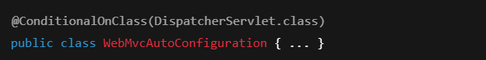 This is how Boot becomes intelligent.

Example — Spring vs Spring Boot (Database)
In Spring (without Boot)
You must write:
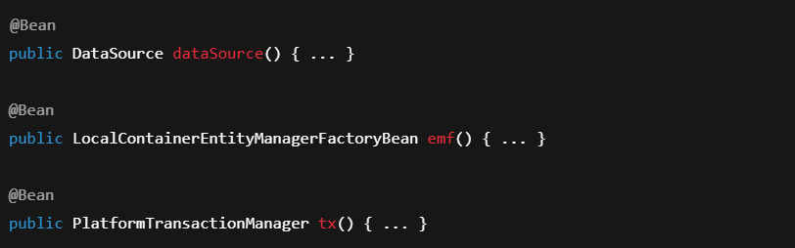

In Spring Boot
You only write:
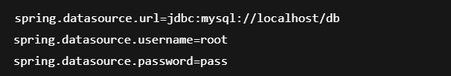
Spring Boot sees:
• MySQL driver
• Hibernate
• JPA starter
And creates everything.

Example — Web Server
Add dependency:
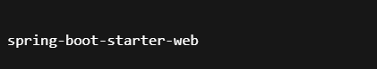
- Boot sees:
• Tomcat
• Spring MVC
• Jackson
- Auto-config creates:
• Embedded Tomcat
• DispatcherServlet
• MappingHandlers
• JSON converters
You wrote zero config.

When Boot Backs Off
If you define:
 Boot sees:
@ConditionalOnMissingBean(DataSource.class) → false
So it does not create its own.
This is called back-off behavior.

Hidden Traps
Problem | Why
Multiple DataSources | Boot disables auto-config
Missing starter | No auto-config triggered
Wrong classpath | Conditions fail
Circular beans | Proxying fails
Custom bean overrides | Boot backs off

Interview Gold
What interviewers test:
They are checking if you know:
• Spring creates beans
• Boot decides which beans
• Conditions control auto-config
• You can override Boot

Summary

1. It starts in pom.xml (Your Intent)
When you add dependencies like:
- spring-boot-starter-web
- spring-boot-starter-data-jpa
- mysql-connector-j
You are not just adding libraries.
You are telling Spring Boot:
“I want to build a web application with REST APIs and a database.”
This is your intent.
You are not writing configuration yet —
you are declaring what kind of system you want.

2. Spring Boot reads your classpath
When you start the application:

Spring Boot first looks at:
- All JARs in the classpath
- All starters you added
- All libraries inside them
From this it learns:
- Web MVC is present
- Tomcat is present
- JPA & Hibernate are present
- MySQL driver is present
Spring Boot now knows what type of application this is.
3. Auto-Configuration JAR wakes up
Spring Boot has a special JAR:
spring-boot-autoconfigure
Inside it are hundreds of pre-written configuration classes, such as:
- DataSourceAutoConfiguration
- WebMvcAutoConfiguration
- HibernateJpaAutoConfiguration
- TomcatServletWebServerFactoryAutoConfiguration
Each one knows how to configure one technology.
This JAR is loaded automatically because of:

(which is inside @SpringBootApplication)

4. Conditions decide what to activate
Every auto-config class is protected by rules like:
“Only activate this if…”
For example:
- Only create Tomcat if Spring MVC exists
- Only create DataSource if MySQL driver exists
- Only create EntityManager if Hibernate exists
- Only create beans if the user didn’t define their own
These rules are implemented using annotations like:
- @ConditionalOnClass
- @ConditionalOnMissingBean
- @ConditionalOnProperty
So Spring Boot is not blindly creating things.
It is checking your project first.
5. Your application.properties fine-tunes the system
Now Spring Boot reads:
application.properties
or
application.yml
Here you give values like:
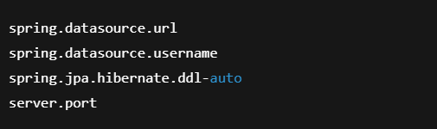
These values are injected into the auto-config beans.
So Spring Boot:
- Already created the DataSource
- Now fills it with your connection URL
- Already created Hibernate
- Now applies your dialect and DDL settings
You are not creating objects.
You are just tuning what Boot already created.

6. IoC Container builds the real application
Now Spring’s core engine (IoC container) takes over.
It:
- Scans your @Component, @Service, @Repository, @Controller
- Creates your beans
- Injects dependencies
- Wires everything together

At the same time, it also registers:
- Tomcat
- DispatcherServlet
- DataSource
- EntityManager
- TransactionManager
- Jackson
- MVC infrastructure
All of these came from auto-configuration.
Your business code and Boot’s infrastructure meet inside the same container.

7. The application is now ready
By the time the server starts:
- Your controllers are ready
- Your services are wired
- Your repositories are connected to DB
- Tomcat is running
- DispatcherServlet is waiting for requests
And you never wrote a single line of configuration for any of it.
This is what Spring Boot really did:
It translated your dependencies + properties into a fully wired enterprise application.

One-line mental model
Spring Framework gives you
→ IoC, DI, MVC, JDBC, JPA
Spring Boot adds
→ “I will configure all of that for you based on what you added.”
You declare what you want.
Spring Boot figures out how to build it.
Most Asked Interview Questions

Q1. What is Auto-Configuration?
Default Spring configs activated based on classpath.
Q2. How is it enabled?
@EnableAutoConfiguration
Q3. Where is it defined?
spring-boot-autoconfigure JAR
Q4. How does Boot know what to configure?
@ConditionalOnClass
Q5. How to override?
Define your own @Bean
Q6. What happens if I define a DataSource?
Boot backs off.
Q7. Why is Spring Boot faster?
Less configuration.
Q8. What loads auto-config?
AutoConfigurationImportSelector
Q9. What file lists configs?
AutoConfiguration.imports
Q10. What is back-off?
Boot not creating beans if user did.

One-Page Mental Model
- Spring → creates beans
- Spring Boot → decides which beans
- Auto-Config → predefined enterprise wiring
- Conditions → rules
- Starters → triggers

Why This Matters in Real Projects
Auto-configuration is why:
• Microservices start in seconds
• Config is minimal
• Teams move faster
• Production systems stay consistent
Every serious Spring Boot engineer must understand this.

